Theoretical catch-pit loading calculations can be provided on request; these are intended only as guidance to facilitate the confirmation of the suitability of a particular catch-pit type in the application expressed.

As AQUA Fabrications Ltd has no control over the design, installation and application of the stated product, we would remind you that it remains the responsibility of the designer/ installation contractor to ensure that products specified are suitable for a given application and installed in accordance with stated requirements.

Once complete please email this form to sales@aquafab.co.uk or your AQUA contact. On receipt we will endeavor to have completed checks sent to you within three working days.

Project Name:

Chamber Information – Circular HDPE Chambers

Catch-pit Type: |  | Catch-pit Depth, H_{total}:
Lid Type:
Base Type:

Chamber Information – Hybrid Catch-pits

Catch-pit Type: |  |  | Catch-pit Depth, H_{total}:
Lid Type: |  |  |  | No. of Raising Frames:
Base Type: |  |  |  | Raising Frame Type:

Chamber Information – Rectangular

Catch-pit Type: |  |  | Catch-pit Depth, H_{total}:
Lid Type:
 |  | Raising Frame Type:
Base Type:

Ground Conditions, including Bed & Surround

Ideal Trench Width, B_{d}: Chamber Width + |  |  |  |  |  |  |  | mm (recommended MIN is 400mm)
Native Soil Modulus, E’₃: |  |  |  |  |  | MN/m² as per Table 13 BS 9295:2020+A1:2025 see below
Angle of Internal Friction, Φ: |  |  |  |  |  | degrees.
Soil Density: |  |  | kN/m³ (Typically 21kN/m³ as per NR/CIV/SD/5102 & NR/L2/CIV/044)
Embedment Class: |  |  |  |  |  |  | as per Table 14 BS 9295:2020 +A1:2025 see below

Loading Conditions

Train Axle Load: |  |  |  |  | kN (typically 250kN as per BS EN 1991-2 Eurocode 1 Actions on Structures Part 2, figure 6.1)
Alpha Factor, α: |  |  |  |  | (For LM71, 1.21 as per NR/L3/CIV/020 & NR/CIV/SD/TUM/5000 B.1.2)
Dynamic Factor, Φ: |  |  |  |  |  | (Typically, 2.0 as per NR/CIV/SD/TUM/5000 B.1.2)
Sleeper Length, mm: |  |  |  |  |  |  | Sleeper Width, mm: |  |  | Sleeper Depth, mm:
Load Spread Angle: |  |  |  |  |  |  |  | Degrees (typically 30º as per NR/CIV/SD/5204)
Track Gauge, mm: |  |  |  |  |  |  | See NR/L2/TRK/2102/12; Design & Construction of Track & NR/L3/TRK/2049; Track Design Handbook for guidance.
Offset Type: |  |  |  |  |  |  |  |  |  | Offset Distance, mm:
*¹ Ideally 1,410mm MIN as per NR/CIV/SD/TUM/5000.
Cover Level (CL)
Bottom of Sleeper (BoS)
Or…
A is
mm Above Sleeper Bottom
Or…
A is
mm Below Sleeper Bottom
*² Typically 1,970mm.

Location of Chamber relative to Bottom of Sleeper

Please use the below to aid in providing information relative to the positioning of the chamber relative to the underside (bottom) of the sleeper.

Cess Applications

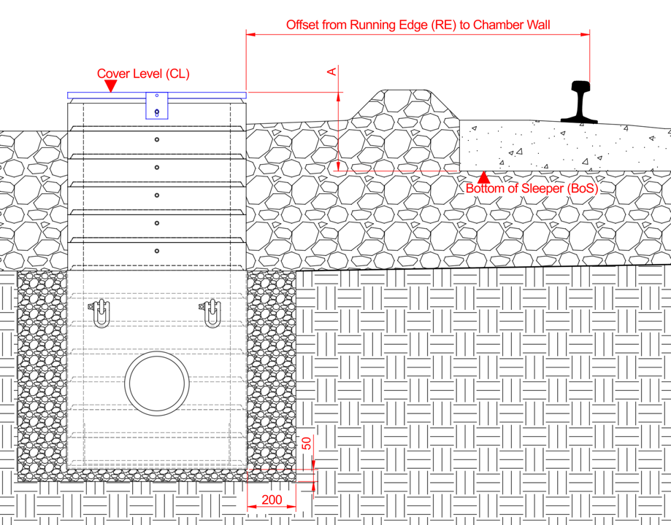

For 6ft applications, see below.

Cover Level (CL)
Bottom of Sleeper (BoS)
Or…
A is
mm Above Sleeper Bottom
Or…
A is
mm Below Sleeper Bottom

6ft Applications

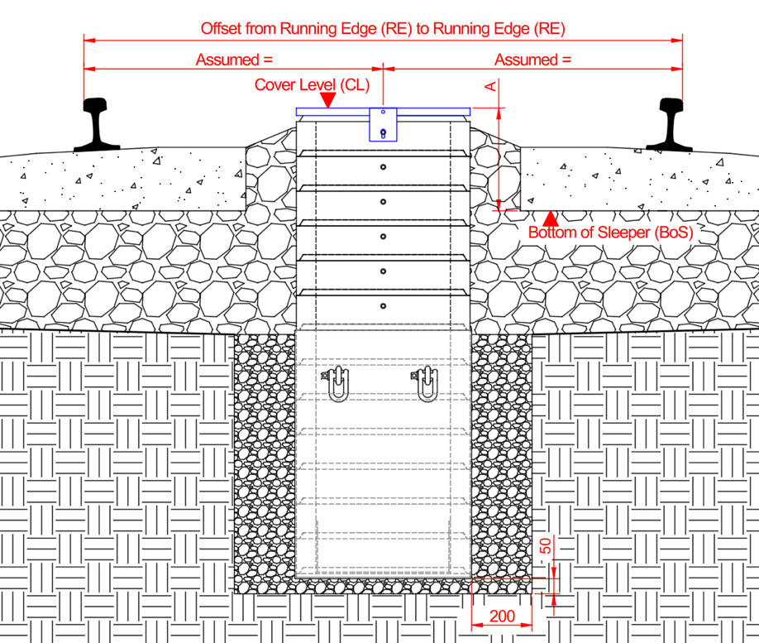
Reference Tables

BS 9295:2020+A1:2025 Table 13 – Native Soil Modulus

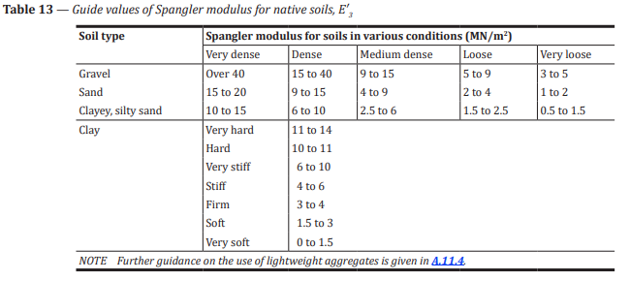

BS9295:2020+A1:2025 Table 14 – Embedment Class

